**Lab 8 Activity 3 - Calculating Total Inventory Cost**

**Objective:** Learn to apply the SUM function to aggregate total costs.

1. Select an empty cell below the Total Price column.

2. Type =SUM(D2:D6) (assuming D2:D6 contains total prices) and press Enter.

3. Format the total cost cell using bold and currency format.

4. Save and close the workbook.

**____________________________________________________________________________________**

**Solutions:**

**Task 1:**

* Click on the first empty cell below your "Total Price" values, e.g., **D7**.

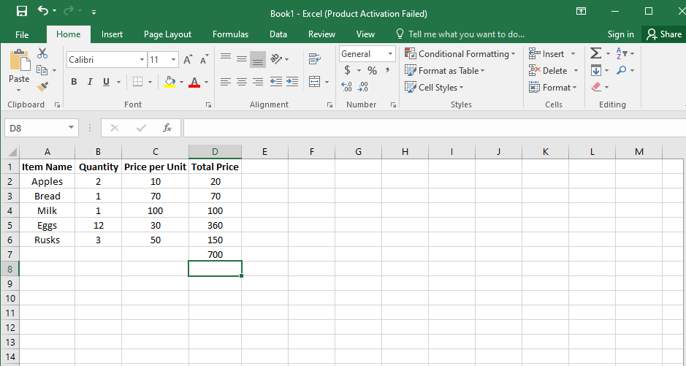**Task 2:**

* Type the following formula: **=SUM(D2:D6)**
* Press Enter. This will calculate the total cost of all items.

**Task 3:**

1. Click on Cell D7 (or the cell where you entered the formula).
2. Bold the text:
3. Press Ctrl + B or click the Bold (B) button on the toolbar.
4. Apply Currency Format:
5. Go to the Home tab.
6. Click the Currency ($) button in the "Number" section.
7. Alternatively, right-click the cell, choose Format Cells, select Currency, and click OK.

**Task 4:**

* Click File > Save to keep the changes.
* Close Excel by clicking the X button in the top-right corner.